Local Government: Townsville City Council
Project Name: Citylibraries Riverway Build and Grand Opening

Project Description
To design, build and launch the Riverway library branch required the library stakeholders to be aware of international public library design and service trends, and to translate that awareness into compelling narratives which could be used in both formal design briefings, and informal discussions with various stakeholders along the entire project timeline. As well as desktop research, library staff attended the three-part Libraries by Design conference in 2021, as well as visiting flagship public libraries during personal travel.

The internal stakeholders engaged included; community members, library staff, council’s executive team, property services, stakeholder engagement, information technology services, procurement team, workplace health and safety, parks and open spaces team, gallery services, community venues team, human resources, marketing team, and protocol and events team. It also included external stakeholders, including; the architect, building contractor and sub-contractors, café lessor, emergency services, cleaning contractors, surf life savers and security contractors.

Once built, a full day of celebrations was scheduled to coincide with Riverway Library's first day of opening to the public. Since the closure of the Thuringowa Library, the opening of the new Library had been a much anticipated event within the Townsville Community.

Choosing a suitable celebrity to help open the library met with challenges as well, however, these questions required the same levels of focused advocacy, to draw a line-of-site from these popular characters to the core business of public libraries.

CONTACT: Nicole Hunt - nicole.hunt@townsville.qld.gov.au

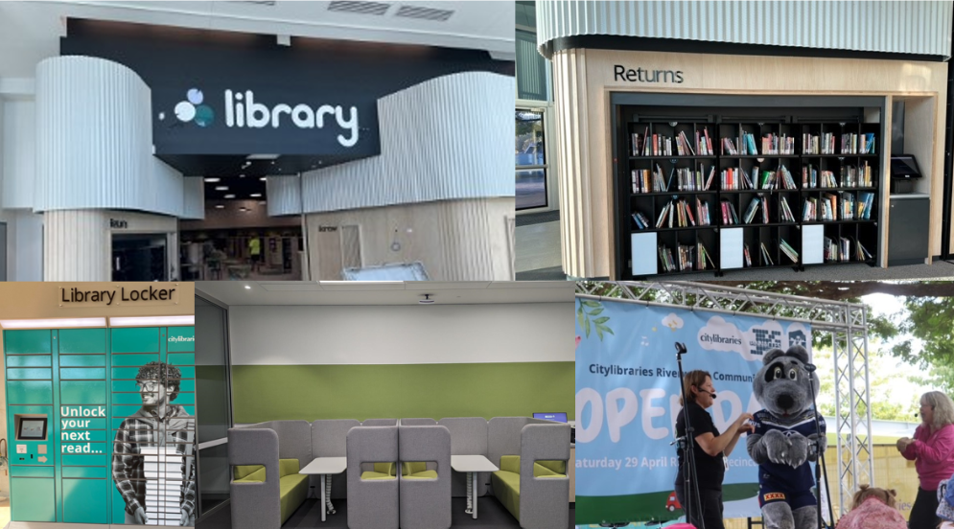

Local Government: Noosa Shire Council
Project Name: Beyond the Walls - transforming a traditional Mobile Library service to a new multi-functional outreach service model

Project Description
With the Noosa Libraries Mobile Library nearing its end-of-life, there was a unique opportunity to explore the way outreach library services were being delivered to the Noosa community and to reshape our approach to ensure our service continued to respond to community needs.

A service review and community consultation showed the Mobile Library was still highly valued with strong community support, however customer needs and habits had changed considerably over the sixteen years, resulting in a decline in visitation, borrowing and overall usage in its current format. It was time to consider an appropriate replacement plan that would provide outreach library services to the coastal and hinterland areas that did not have a branch library in close proximity.

After reviewing a range of replacement options, Council endorsed replacing the Mobile Library with a hybrid or combination of library outreach services. These included a smaller, more versatile vehicle, two book-vending kiosks, increased house-bound services and a suite of learning programs delivered throughout the shire.

The new kiosks, hosted in the Community Houses at Pomona and Peregian Beach, each hold up to 200 items, and with a simple touchscreen can guide users through the borrowing and return process. Outreach programming has complemented the new kiosks and helped activate and promote the new service.

Both the kiosks and new vehicle are branded with artwork by a First Nation’s artist, author and storyteller – providing an opportunity to show our respect to the traditional custodians of the land.

The new outreach service model has provided an exciting opportunity for Noosa Libraries to deliver innovative library services using 21st century technologies and transition a conventional Mobile Library service into a multifaceted outreach service model. This has expanded services beyond the library's physical walls and further into the Noosa Shire region as well as mitigating identified risks around resourcing, accessibility and legislative requirements and responsibilities.

CONTACT : Tracey King tracey.king@noosa.qld.gov.au

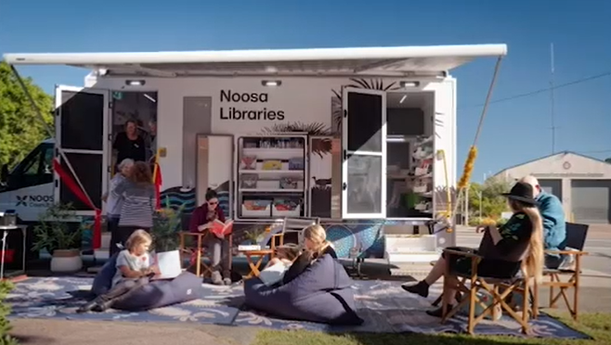

Local Government: Paroo shire Council
Project Name: The Evolution of Cunnamulla Library

Project Description
Prior to the opening/renovation of the children's area the library was very small, making it very hard to have any programs. But we did. We couldn't do any kids' programs other than Reading Club because we simply didn't have the room. The kid' s area consisted of a small table with 4 chairs in the left-hand corner of the library. We had one little tub of picture books and two small upright shelving units for junior/young adults. Fast forward to 11 years later and our library space has totally been transformed.

It Is a light, bright, colourful, large open planned space that now easily enables us to hold the following programs; Weekly First5Forever program, whole school class robotic workshops, private modern public computer/printer spaces, soft play gym set for our little people, LOTS of book shelving, innovative curved customer service desk with plenty of room for staff members and storage and a returns slot, innovating READ shaped shelving, user friendly lower "S" shaped shelving in the adult area, containing a huge ottoman for our patrons to sit and peruse or do quiet reading. As well as a community noticeboard, bright slat wall for opening displaying magazines, an additional toilet that is wheelchair accessible, a lovely second seating area with tub chairs and a coffee table for tourists that has access to USB/power points. We have a storeroom with shelving to accommodate our vast array of robotics as well as 4 metres of closed in shelving behind our desk area for tidy storage of extra robotics, books, stationary etc.

We are extremely proud of our new look space, as are our community members and tourists, which our 100% survey results show.

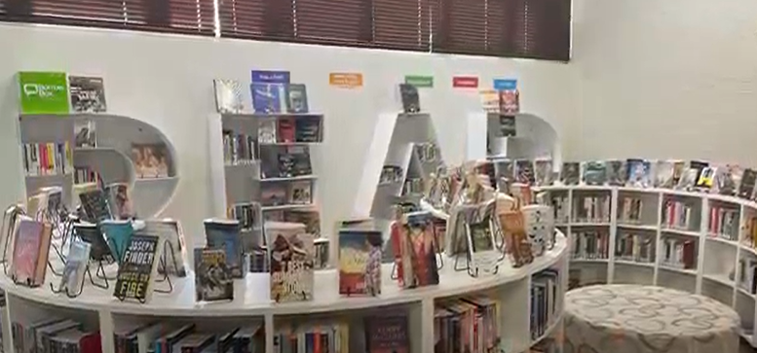
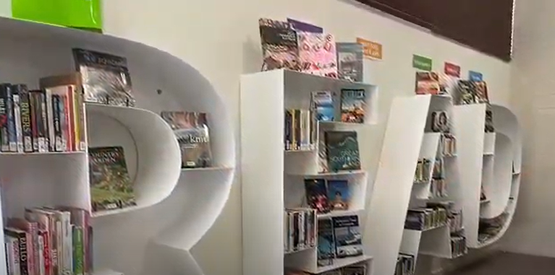
CONTACT: Tammy Hickey

Local Government: Ipswich Regional Council
Project Name: Picturing Your Past

Project Description
Picturing Your Past delivered 4 physical installations across 4 of our locations with a look, feel and configuration that encourages ongoing engagement with Ipswich Libraries services and resources. Each installation project includes a PC touchscreen with access to digital games that incorporate images from Picture Ipswich, retro mid-century era staging and props that reflects a bygone time, and additional disability compliant seating to encourage deep engagement and extended exploration with diverse audiences. Picturing Your Past also delivers several self-directed printed activities which align with the Queensland primary school curriculum. These activities aim to support participation, stimulate ideas, encourage problem solving, deep diving and discovery of Picture Ipswich website, whilst also considering the varying learning styles and abilities of our community. This immersive project will celebrate the diversity of our culture and encourage reflection on our history.

The Picturing Your Past project has many ongoing benefits and outcomes. Ipswich Libraries hope to see increased participation with library resources and services and increased engagement with Ipswich’s cultural heritage. Another benefit of this project is the increase of opportunities for schools to engage with their local library service. This project also allowed staff the opportunity to develop their knowledge and awareness of local history research practices, whilst also developing close working relationships between Library Branch Services staff and other areas of Council. It is hoped that the suite of activities that have been developed by staff will promote information literacy skills, encourage inter-generational conversations and relationship development, and promote critical thinking and analysis. Finally, it is also hoped that these installations will encourage community contributions of contemporary Picture Ipswich content to this website, therefore increasing exploration of physical heritage elements and buildings in the Ipswich area.

CONTACT: Erin Davey erin.davey@ipswich.qld.gov.au

