Local Government: Bundaberg Regional Council
Project Name: Ability Diverse Programming

Project Description and Goal
Programming to create inclusivity for community members using an Ability Diverse Model. The goal of the project is to create more inclusion, diversity and engagement.

The Ability Diverse Program takes an active rather than a passive approach to this concept so that inclusion visibility is foremost and celebrated. As such we feel that it aspires to the future of diverse and inclusive libraries and active engagement with participants and service providers so that the maximum relationship benefit is achieved. Previously Ability Diverse customers would utilize the library space but may have felt that they were excluded from programs due to the general and stereotypical nature of library marketing material. The program was created to specifically address a section of our community and create an inclusive design around that community rather than a general community inclusion statement. This approach has created awareness and interaction with multiple members of the library community. Our staff have developed targeted skills that will be relevant for a sustainable industry based on quality education and strong institutions. The program creates dynamic growth in an area that builds information skills in fields such as the philosophy of emerging technologies, creativity, and play based learning. It is hoped that the program will create ripples that expand to all libraries and help shift consciousness towards more social solutions in community engagement.

Project Synopsis
The Ability Diverse Program suite is delivered on the last Monday of every month and is comprised of a variety of activities. Activities so far have included Robotics, Storytime with cat craft and a robotic cat, cartooning lessons with Phantom artist Shane Foley, Virtual Reality Gaming with Acron: attack of the squirrels on the Oculus 2 and iPads. Future events include Halloween party, Everyone is Awesome Lego and Love Hearts, Christmas Party. The program was conceptualized and instigated by Library Assistant Wendy Clifford and is championed by librarians, IT staff and library assistants. Program sessions are facilitated and supervised by trained staff as well as support workers or guardians.

Outcomes for the program have included increased relationship building with participants, community, staff and stakeholders. For our staff it has increased our skillset, developed empathy and understanding, fostered a sense of pride and ownership in creating programs that support our community and rallied a want to advocate for the principles and ethics of the library industry as a whole.

We learnt that we need to do more as libraries to be fully inclusive and engaging. We have to embrace experimentation and treat our experience as fluid and ever changing. Ability Diverse Programming will continue at Bundaberg Regional Libraries and will evolve and adapt to changes within our community to reflect the needs of our customers and partners.

CONTACT: Jaala Beauchamp - jaala.beauchamp@bundaberg.qld.gov.au

Local Government: Noosa Shire Council
Project Name: The Library Bookshelf Project

Project Description and Goal
The new book-vending kiosks help to reinforce and advocate Noosa Library Service’s role as an innovative, inclusive and highly accessible service. Hosting the kiosks within the community houses at Peregian and Pomona has created an opportunity for strong community partnerships which also provides additional support and promotion of library services. The launch of the new kiosks represents an opportunity for positive publicity and the potential to increase library membership rates within the Noosa Shire.

The introduction of these express, self-service kiosks takes the library service beyond the physical walls of the library and out into the community – to meet people where they are. They provide an innovative service model that fills the gap between permanent full-service library branches and traditional mobile or outreach services.

The kiosks use 21st century technology-enabled solutions to enhance access to library items in convenient community settings. The intuitive self-service solution delivers an easy and engaging experience for people of all ages and abilities – making borrowing and returning library items even more enjoyable.

As part of the branding for the new community outreach service, the new kiosks are each named the “Library BookShelf”. This denotes a community feel, while ensuring clear alignment with the Noosa Library Service. Additionally, the graphic design artwork for the kiosk wrap has included a First Nation’s design by Gregg Dreise, which will also be showcased on Noosa’s new outreach vehicle.

Project Synopsis
After 16 years, Noosa’s Mobile Library has reached its end of life. A service review and community consultation showed the Mobile Library was still highly valued with strong community support, however customer needs and habits had changed considerably over the sixteen years, resulting in a decline in visitation, borrowing and overall usage in its current format. It was time to consider an appropriate replacement plan that would provide outreach library services to the coastal and hinterland areas that did not have a branch library in close proximity.

After reviewing a range of replacement options, Council endorsed replacing the Mobile Library with a hybrid or combination of library outreach services. These would include a smaller, more versatile vehicle, two book-vending kiosks, bulk loan services to partner organisations and a suite of learning programs delivered throughout the shire.

Noosa Library Service is excited to have recently launched the BookShelf @Peregian - the first of the two library book-vending kiosks that will be installed within Noosa Shire.

The BookShelf @ Peregian is located in the foyer at the newly constructed Peregian Beach Community House and the second Library BookShelf kiosk, which will be up and running within the next few months, will be located inside the Pomona Community House.

Peregian and Pomona were chosen as locations as they are our two busiest Mobile Library locations. Community Houses sit in the heart of these locations, providing access to social, support and learning services to a wide cross-section of these communities, making them an ideal location to provide access to library services.

The self-service BookShelf kiosks, supplied by Quantum Library Supplies, contains a range of popular and recently published fiction, non-fiction, and junior books and holds more than 200 items. Borrowers can view the item’s available to borrow, swipe their membership card to open the door, take the items they want and the door automatically closes. The system works in reverse when items are returned, and the kiosk is re-stocked as books are borrowed and returned to the cabinet. A returns chute is provided to accommodate oversized library items that don’t fit within the kiosk.

Artwork from local first nations artist and author/illustrator Gregg Dreise, is featured as part of the kiosk design. Gregg has written and illustrated a series of children’s books and his artwork on our library kiosks builds upon the artwork he created for our children’s membership cards. We are thrilled to be able to showcase his work on the new BookShelf kiosks.

This new service model provides a unique opportunity to reshape delivery of outreach library services, take advantage of emerging technologies and extend the reach of library services into the broader community.

CONTACT : Tracey King tracey.king@noosa.qld.gov.au

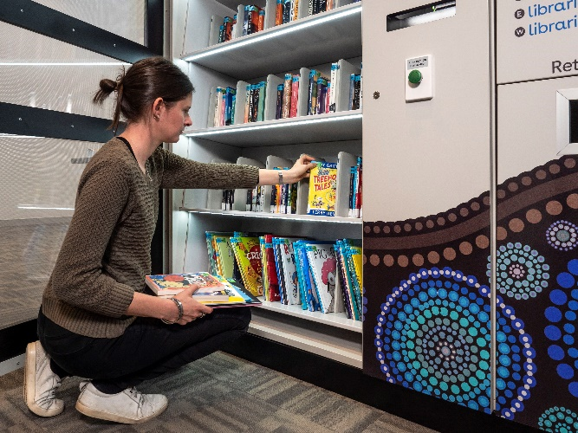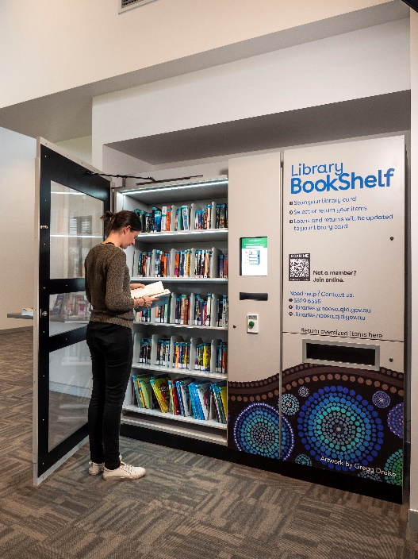

Local Government: Townsville CityLibraries
Project Name: Tropix Talks

Project Description and Goal
Tropix Talks podcast linked with a range of internal (Planning & Development, Digital, Legal, Marketing and Media) and external stakeholders, including State Library Queensland, Asia Pacific Architecture Pacific Festival, local architecture businesses (Place Design Group, i4 architecture, and Counterpoint), and creator of theme music for the podcast, Ryan Fracchia. This advocated library services to stakeholders who had not previously considered public libraries in the areas of podcasting and architecture.
Tropix Talks was Council’s first podcast. Library staff developed new skills including interviewing techniques, using recording technology, sound editing, podcast publishing, purchasing music for the podcast, collaborating with stakeholders, and building a knowledge of architecture to conduct the interviews. The Tropix Talks podcast series opens additional opportunities for Townsville CityLibraries to grow our digital footprint while connecting with our community and beyond to promote small businesses within our community.
The podcast provided library content on a new digital platform linked to our digital life philosophy that promotes and grows Council initiatives, and improves community engagement with the sharing of local stories. New skills will allow staff to deliver other digital services and paves the way for future library digital content creation and publishing.
Townsville CityLibraries has invested in a creative digital studio at Aitkenvale Library. Additional studios will be built as part of the renovations at the proposed Riverway Library in 2023. The podcast is an inexpensive way to connect the community to events and programs promoting other services and priorities for Townsville City Council departments.

Project Synopsis
Tropix Talks Podcast began as the Covid-19 pandemic unfolded. In 2020 Townsville CityLibraries was excited to be involved in hosting international architect Erik L’Heureux from Singapore, as part of the Asia Pacific Architecture Festival. Unfortunately the day before the festival launch Erik had to stop his travel due to travel restrictions brought on by the pandemic.
In 2021, library and council staff did not want to miss out on the opportunity to be part of the architecture festival again, however we knew there was still risks to scheduling in-person events and presentations.

Feedback from our community indicated that they were starting to become overwhelmed with online video content, which requires focused time to watch.
Townsville City Libraries had recently invested in a digital studio at Aitkenvale Library, and staff were starting to see our community using the space, but with all the changes to our services and programs, staff were struggling to deliver new programs and services from that new digital space.
The idea to produce a podcast was developed to address the two challenges of 1) providing digital content in an easily consumed format, and 2) developing staff skills to make use of the studio and produce new programs and services.

The budget for the podcast project was small, and the skill set for staff was gently growing, however staff were ambitious to create and launch Townsville City Councils first podcast for the 2022 Asia Pacific Architecture Festival.

The idea for the podcast was to explore building design and the architecture profession in regional tropical city. The podcast episodes feature interviews with local architects Zammi Rohan, Mark Kennedy, Hywel Jones and Jon Larrazabal, coving what drives and inspires them, their local experiences, their careers and their favourite local and internal projects.
Through the interviews we found out about local buildings that they had turned into workspaces. A prominent theme of shade for a city was ever prevent in their future planning.

CONTACT: Nicole Hunt nicole.hunt@townsville.qld.gov.au

Local Government: Western Downs Regional Council
Project Name: Shout Out! Youth Storytelling Competition

Project Description and Goal
The project provided us an opportunity to engage with our local youth and lift our profile in the
notoriously hard-to-reach demographic. As well as engaging with their families.
It allowed us to further build relationships with schools, principles, teachers and Head of Departments.
We collaborated with external parties, videographer, graphic designer, presenters. As well as internal
parties; library branch staff, WDRC Communications and Marketing department, WDRC Councillors
and WOW staff.

Project Synopsis
In July 2021, Western Downs Regional Council were successful in attaining a Mental Health and
Wellbeing grant from Queensland Health to deliver localised mental health responses to enhance
wellbeing and re-establish community connectedness. As a part of this grant, the Shout Out! Youth
Storytelling Competition was developed to showcase the resilience and talent of our region's youth.

The competition was open to young people aged 13 to 18 who live, work or study with the Western
Downs. In collaboration with local high schools, students were encouraged to submit their stories
(Written or verbal) on rural resilience and mental wellbeing arising through community connectedness:
in short, how they have overcome challenges and gained resilience through the help of their
community. Promotion also extended to boarding school students, home schoolers and school
leavers within the age category, as well as caregivers of these young people.

To assist with the creation of their stories, Western Downs Libraries provided digital 'support kits' —
including learning resources, stimulus materials, and access to an online workshop video — through
the duration of the competition. The online workshop video was created with ABC presenter, Lydia
Burton, who grew up in the Western Downs and attended school in Dalby.

From all entries, a panel of judges selected three finalists to have their stories professionally produced
into a short video and premiered at Words Out West: Western Downs Readers & Writers Fest 2022.
Clancy Sinnamon was our videographer for the project, being a rural 'bush kid' himself he connected
incredibly well with the finalists to bring their stories to life.

CONTACT: Chris Bermingham Chris.Bermingham@wdrc.qld.gov.au

