WHERE THE WILD THINGS ARE
Practical strategies for dealing with the worst customers, growing resilience and staying safe
PROGRAM
MONDAY – 24 SEPTEMBER 2018 Day One
8.30 – 9.00 am Arrival and registration
9.00 – 9.15 am Official welcome and introduction
Session 1: We Need To Talk About Kevin (and all the other ones…)
Topic: Dealing with Aggressive and Difficult Customers (3 workshops)

9.15 – 10.15 am The first 3 workshops will form Session 1 and will cover
Workshop 1:
- Aggressive people
- Setting boundaries
- Reporting and action plans
10.15 – 10.45 am Morning Tea
10.45 – 11.15 am Session 1 continued. Workshop 2:
- Satisfactory outcomes – responding not reacting, and staying safe
- Personality conflict

11.15 – 12.15 pm Workshop 3:
- Communicating with Difficult Customers
- Understanding anger and frustration
12.15 – 1.15 pm Lunch
Session 2: Extremely Loud and incredibly Close
Topic: Team Effectiveness (2 workshops)

1.15 – 2.15 pm Workshop 4:
- What is an effective team and how does your team rate?
- Understanding self and others – motivations, boundaries and communication
2.15 – 2.30 pm Afternoon Tea
2.30 – 3.30 pm Workshop 5:
- Team relationships – different motivators and generations, struggle points and strategies for trust
3.30 pm Summary and close of Day One
3.45 pm Library tour
- Guided tour of the new Springfield Central Library with Library Services Manager, Sylvia Swalling
5.00 – 6.30 pm Social Event
- Wine and cheese while enjoying the new library space
TUESDAY – 25 SEPTEMBER 2018 Day Two
8.00 – 9.00 am Breakfast and QPLA AGM

TUESDAY – 25 SEPTEMBER 2018 Day Two
9.00 – 9.15 am Arrival and registration
9.15 – 9.30 am Official welcome and introduction
Session 3: The Subtle Art Of Not Giving Up
Topic: Resilience in the Workplace (Keynote address, Panel Q&A, 2 workshops)

9.30 – 10.15 am Keynote Address
Presenter: Andrew May (author of Flip the Switch and Performance matters blog)
- Andrew is recognised as Australia’s leading expert on workplace performance. He will deliver an energetic and inspirational keynote address around productivity, wellbeing, employee engagement and resilience.

10.15 – 11.00 am Panel Q&A
Mediated by Matthew Barry from Preferred Training Networks
- Policy and governance around staff wellness, resilience and handling difficult customers

11.00 – 11.30 am Morning Tea
11.30 am – 12.30 pm
- Panel Q&A continues

12.30 – 1.15 pm Workshop 6:
- Resilience in the workplace – milestones and building team resilience
- The Resilience Inventory – signs, impacts and influence

1.15 – 2.15 pm Lunch
2.15 – 3.15 pm Workshop 7:
- Personal resilience – respond vs react
- Emotional control
- Techniques for developing resilience
- Strategies for managing clients
- Bouncing back after dealing with difficult and highly emotional people

3.15 – 3.30 pm Summary and close

KEYNOTE SPEAKER – ANDREW MAY

Andrew is a serial entrepreneur and is recognised as Australia’s leading expert on workplace performance. He is a Partner of KPMG’s Performance Clinic assisting organisations to enhance productivity, wellbeing and employee engagement through the high performance of their people.
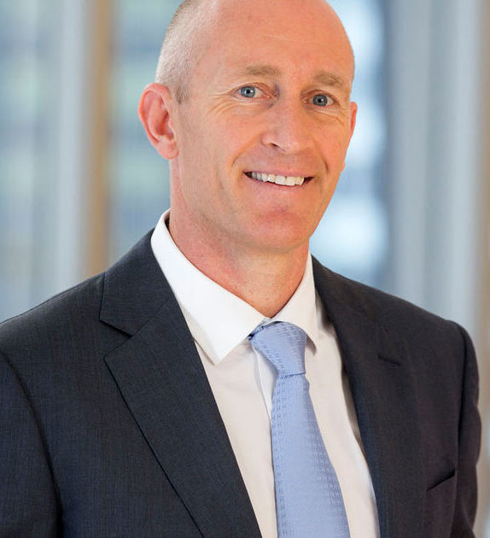
Andrew is the author of the bestselling book Flip the Switch, writes a popular blog Performance Matters for The Sydney Morning Herald and The Age, has a regular segment on ABC News Breakfast and appears regularly on Channel Nine. Andrew delivers energetic and inspiring keynote presentations and workshops around the world.
Arrangements made through Celebrity Speakers www.celebrityspeakers.com.au

PREFERRED TRAINING NETWORKS
Preferred Training Networks (Preftrain) provides the largest breadth of professional development courses in Australia. Preftrain is an Australian company and, as a partner in training, can provide risk-free quality learning solutions to help people operate more effectively.
Preftrain has extensive experience in the development, design and delivery of professional development programs for a range of organisations across Australia. Central to their success is the ability to highly contextualise programs by incorporating the client’s internal structures, frameworks and processes into the programs. Preftrain is committed to offering the finest training solutions and believes learning needs to be across all facets of an individual’s working journey.
TRAINER – MATTHEW BARRY
Matthew is one of Preftrain’s most experienced and qualified Senior Trainers/Facilitators, with over 20 years’ experience working in learning and development in both facilitation and management roles. He has a BA Arts, Graduate Diploma in HR Management and Industrial Relations, Accredited in Herrmann Brain Dominance Indicator, Accredited in DDI Success Profiles and is a Certified Practitioner Australian Human Resources Institute (CAHRI).
Matthew is an expert facilitator and coach, specialising in organisational development and learning. Over the last 20 years, he delivered results across multiple industries and countries, with experience advising from the shop floor, to senior executive levels. Matthew’s passion is assisting clients to think in more performance-oriented ways and develop their skills in self-sufficiency, resilience and results orientation.

SPRINGFIELD CENTRAL LIBRARY
Springfield Central Library is the long awaited new branch of Ipswich Libraries. It was officially opened in August 2018 and celebrated with a Welcome Weekend of events and activities culminating with an evening in the company of Australia’s internationally bestselling author, Matthew Reilly. This incredibly exciting, engaging and innovative community space features:
- Something for everyone in our unique bookshop styled Marketplace with dozens of curated special collections
- A hi tech Makerspace showcasing cutting edge digital experiences including virtual reality, augmented reality, 3D world-building and making your own instant movies
- An enchanting beautiful new children’s space with a dedicated parent’s room
- Two bookable events rooms, training room for 20 and 4 meeting spaces
- Bookable public PCs with printing facilities
- Dozens of quiet nooks, desks and booths in which to hide away
- Tens of thousands of hi-quality books, magazines, comic books, DVDs and electronic resources available to everyone.

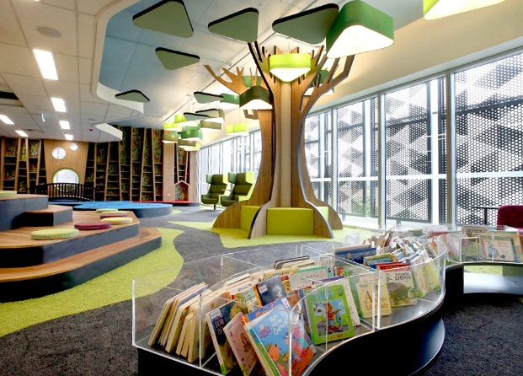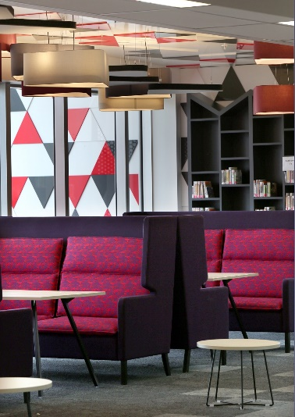

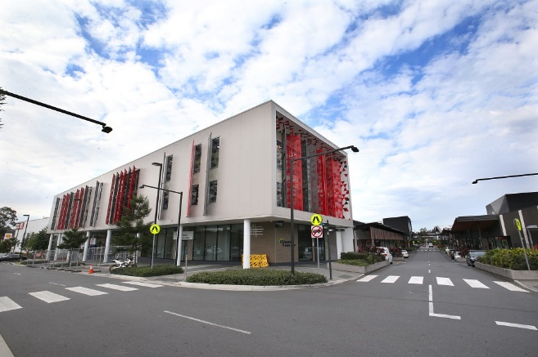
Location:
Orion Springfield Central
Cnr Sirius Drive and Main Street,
Springfield Central QLD 4300
https://goo.gl/maps/37xK19Kzm8k

The library can be accessed from Main Street (just up from the Post Office). Underground car parking is available off Sirius Drive with access to the library via the lift to Level 1. Car parking is also available across from the library off Sirius Drive with access via the foyer off Main Street.
Springfield Central Library is also easy walking distance from Springfield Central railway station.

